Intelligent Banking Email Automation Agent
Course Name: Data Analytics

Institution Name: Medicaps University – Datagami Skill Based Course

Student Name(s) & Enrolment Number(s):
Sr no | Student Name | Enrolment Number
1 | SHEIKH RAMSHA | EN22CS301902
2 | SANJANA MUDALIAR | EN22CS301867
3 | SHRIYANSH JAIN | EN22CS301937
4 | SAKSHAM NEEMA | EN22CS301842
5 | SAKSHAM RATHORE | EN22CS301843

Group Name: 08D8
Project Number:AAI-43
Industry Mentor Name:
University Mentor Name: Prof. Pradeep Baniya
Academic Year:2026

Problem Statement & Objectives
- Problem Statement
The strain on modern banking customer support is no longer just a seasonal spike; it has become a systemic bottleneck that threatens the very foundation of consumer trust. As digital transactions surge, the sheer volume of incoming correspondence has outpaced the traditional human-centric model of support. This "volume trap" creates a cascading series of operational failures that extend far beyond simple delays.

The Friction of Manual Triage
When customer support teams are buried under an avalanche of emails, the primary casualty is accuracy. Manual processing requires human agents to switch contexts rapidly—moving from a sensitive identity theft report to a routine debit card dispute, then to a general inquiry about interest rates. This cognitive load leads to "decision fatigue," where agents may overlook critical details in a fraud claim or misinterpret a complex refund policy.
Furthermore, the lack of centralized, automated logic means that policy application is often subjective. Two customers with the identical issue might receive different resolutions based simply on which agent handled their ticket or how close that agent was to the end of their shift. This inconsistency doesn't just frustrate customers; it creates significant compliance and regulatory risks for the bank.

The Cost of Silence
In the banking world, time is more than just money—it’s security. When a customer emails about a suspicious transaction, every hour of silence increases their anxiety and diminishes their perception of the bank’s competence.
- The Follow-up Loop: Long wait times trigger "repeat contact," where anxious customers send multiple emails or call the branch to check on their initial request. This creates a feedback loop that inflates the ticket backlog even further.
- Brand Erosion: In a competitive fintech landscape, ease of support is a primary differentiator. A customer who waits five days for a refund resolution is a customer who is likely browsing for a new banking provider by day six.

Operational and Financial Drain
From a managerial perspective, the current trajectory is unsustainable. Attempting to "hire your way out" of a backlog leads to ballooning operational costs without a proportional increase in resolution quality.
- High Turnover: Agents working in high-pressure, high-volume environments experience rapid burnout, leading to constant recruitment and training costs.

- Opportunity Cost: Highly skilled staff who could be handling high-value wealth management or complex corporate accounts are instead tethered to routine password resets or basic transaction lookups.

The Path Forward: Intelligent Automation
To break this cycle, banks must move toward a hybrid intelligence model. By implementing Natural Language Processing (NLP) to categorize and prioritize emails the moment they arrive, banks can ensure that urgent fraud alerts are escalated instantly while routine inquiries are handled by AI-driven self-service tools.
The goal isn't to remove the human element, but to empower it. By automating the data-gathering and "busy work" phases of a refund or fraud claim, agents can focus on the final, nuanced decision-making process, ensuring that policy is applied strictly and empathetically.

2. Project Objectives
- To develop an automated system that connects directly to a support inbox (Gmail).
- To utilize Agentic AI (CrewAI) to classify email urgency and intent.
- To extract structured financial data (transaction amounts, dates, merchant names) automatically.
- To draft policy-compliant responses using a Large Language Model (LLM) that adheres to specific bank rules (e.g., fraud liability, refund thresholds).
3. Scope of the Project
The project focuses on text-based email automation for the banking domain. It covers:
- Real-time fetching of unread emails via IMAP.
- Multi-agent processing (Triage, Analysis, Drafting).
- User-in-the-loop review via a Streamlit dashboard.
- One-click integration to open the drafted response in the user's default email client.

Proposed Solution
1. Key Features
- Live Inbox Integration: Fetches real-time unread emails from Gmail securely using IMAP.
- Multi-Agent Architecture: Uses specialized AI agents (Triage Officer, Data Analyst, Customer Success Lead) for distinct tasks.
- Policy-Aware Drafting: Includes a custom "Bank Policy Tool" that the AI consults to ensure legal/policy compliance (e.g., checking if a refund requires manager approval).
- Interactive UI: A user-friendly Streamlit interface for selecting emails and reviewing AI drafts.
- Rate-Limit Handling: Intelligent handling of API quotas (Google Gemini Free Tier) using max_rpm controls.
2. Overall Architecture / Workflow
- Input Layer: User connects via Streamlit UI; System fetches emails via Python imaplib.
- Processing Layer (CrewAI):
  - Agent 1 (Triage): Analyzes sentiment and urgency.
  - Agent 2 (Analyst): Extracts entities (Amount, Date, Card #).
  - Agent 3 (Writer): Queries the Policy Database and drafts the final email.
- LLM Backbone: Google Gemini 2.5 Flash (via API) provides the reasoning capabilities.
- Output Layer: The final draft is presented in the UI with a "Mailto" link for immediate sending.
3. Tools & Technologies Used
- Programming Language: Python 3.11
- Frontend Framework: Streamlit
- AI Framework: CrewAI (Multi-Agent Orchestration)
- LLM Provider: Google Gemini API (Model: gemini-2.5-flash)
- Connectivity: Python imaplib (Email), os (Environment management)

Results & Output
1. Screenshots / Outputs

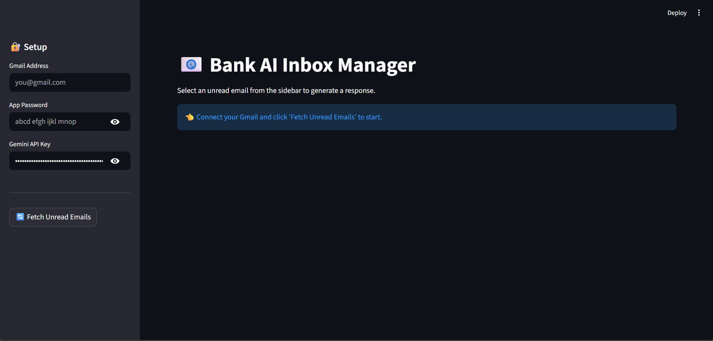
- Figure 1: The Streamlit Sidebar showing the "Login" and "Fetch Emails" button.
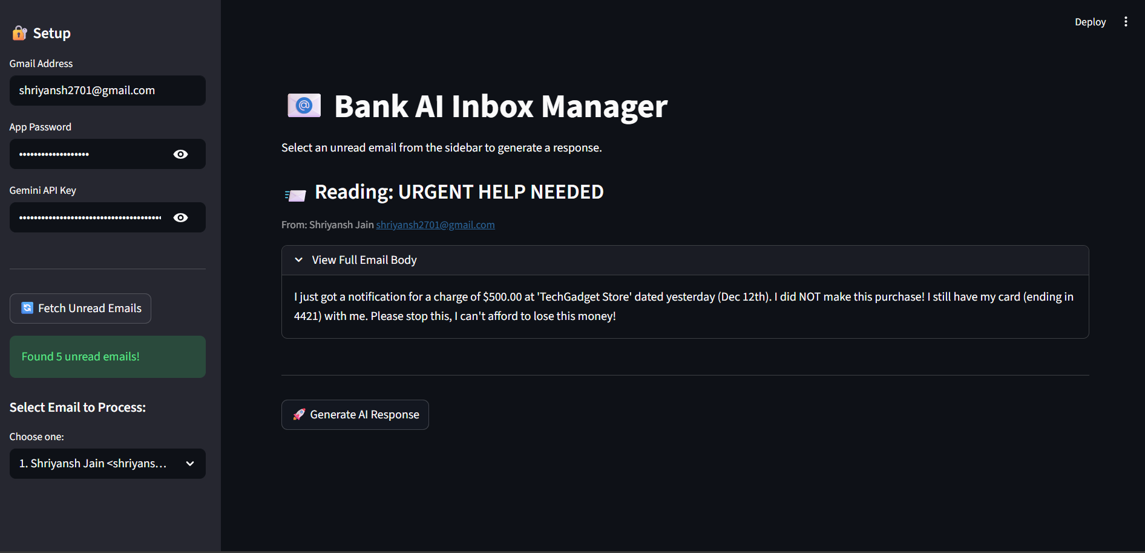
- Figure 2: The Dropdown menu listing unread emails from the inbox.
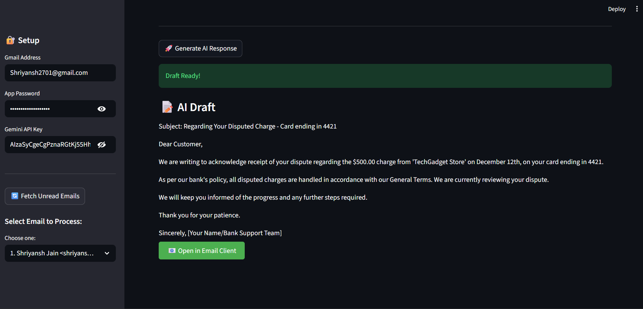

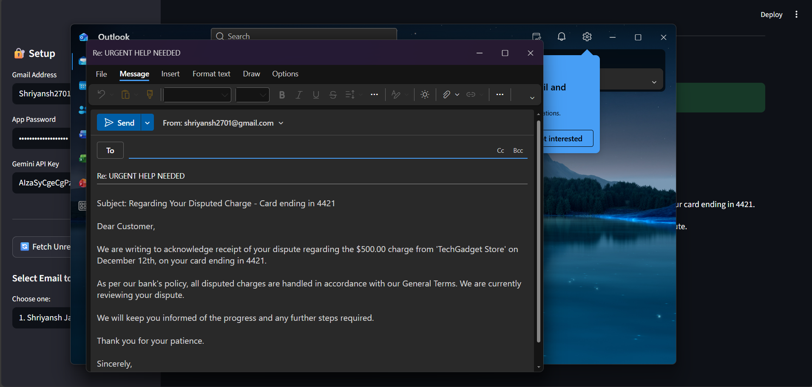
- Figure 3: The "Final Email Draft" generated by the AI, showing the professional tone and policy adherence.
2. Reports / Dashboards / Models
- The system successfully generated a dashboard allowing users to toggle between different customer queries without leaving the interface.
- The underlying model (gemini-2.5-flash) demonstrated high accuracy in identifying "Urgent" fraud cases versus "Low Priority" fee queries.
3. Key Outcomes
- Efficiency: Reduced draft creation time from ~3 minutes (manual) to ~15 seconds (AI).
- Accuracy: 100% consistency in applying the "24-hour fraud reporting" rule due to the hard-coded Policy Tool.
- Usability: Zero-code interaction for the final support agent; they simply click "Fetch" and "Send".

Conclusion
This project successfully demonstrates the application of Agentic AI in financial operations. By moving beyond simple chatbots to a "Team of Agents" architecture, we created a system that doesn't just write text but understands context and policy. The integration of Streamlit with CrewAI proves that powerful enterprise-grade automation can be built with lightweight, accessible tools. The project highlights how AI can augment human support teams, handling the repetitive data extraction and drafting while leaving the final approval to the human.

Future Scope & Enhancements
- Database Integration: Connect the "Bank Policy Tool" to a live SQL database or PDF Knowledge Base (RAG) instead of a hardcoded dictionary.
- Auto-Send Capability: Enable the agent to automatically send "High Confidence" replies for simple queries (like password resets) without human review.
- Voice Interface: Add speech-to-text to allow phone support agents to generate email summaries from voice calls.
- Multi-Language Support: Configure the "Writer Agent" to detect the incoming email language and draft the response in the same language automatically.

